GLOBAL QUEST TECHNOLOGIES



**PAYTM - CLONE**

Using HTML &CSS

**P.Srithish**

**(GQT-SO173)**

Under the Guidance of Trainer

**KESHAV**

(Web Development trainer at GQT)

____________ ____________

Signature of Trainer Signature of CEO(GQT)

# Paytm - Clone

# Scope of the Document

In an era where digital transactions and e-commerce have become integral to our daily lives, I embarked on a journey to develop a Paytm clone, a web-based application crafted with HTML and CSS. This project aims to replicate the seamless user experience and functionality of the popular digital payment platform while showcasing my front-end development skills.

**Key Features:**

**User-Friendly Interface:** The project boasts an intuitive and visually appealing user interface, mirroring the ease of use that Paytm users are accustomed to.

**Secure Transactions:** While this is a clone project, security remains paramount. The application ensures that user data and transactions are handled securely.

**Mobile Responsiveness:** The responsive design guarantees that users can access the platform effortlessly across various devices, be it desktop or mobile.

**Technologies Used:**

**HTML:** The foundation of the project, HTML, forms the structure and content of the web pages.

**CSS:** CSS brings life to the project by styling and beautifying the interface, ensuring a polished and professional appearance.

This Paytm clone project is a testament to my commitment to creating user-centric web applications while staying updated with industry best practices in front-end development. Feel free to explore the project, and don't hesitate to reach out for further details or collaboration opportunities.

**INTRODUCTION:**

**History of HTML**

HTML stands for Hyper Text Markup Language.

* It is used to share the information over the internet.
* HTML id developed by Tim Berner’s Lee in 1991.But officially in 1993.
* The First version of HTML consists of “18 tags”
* HTML follows certain rules and regulations setup by “ISO”.(International Organization for standardization). These set of rules and regulation are present in ‘SGML document’.

**Versions of HTML**

1. HTML-1 version in the year 1993.
2. Html-2 version in the year 1995.
3. HTML-3.02 version in the year 1997.
4. HTML-4.1 version in the year 1999.
5. HTML-5 version in the year 2014

**Features of HTML**

* It is easy to Learn.
* It is a tag based language.
* HTML is supported by multiple browsers.
* First web browser is Netscape navigation which was developed by the “Mosiac”.
* It is a portable language.
* WORA (write once run anywhere).

**Limitation of HTML**

* HTML has less designing capabilities.
* It is dependent on other technology such as CSS in order to develop well designed Web pages.
* HTML has no programming capabilities.
* Using HTML and CSS we can develop only static Web page.
* In order to write the HTML code required an editor such as VS Code, Notepad, Eclipse.
* In order to execute the HTML code we required Web browsers.Like Chrome, Firefox, edge, Opera Safari .

**CSS**

* CSS stands for Cascading Style Sheets.
* It was developed by W3C to add stylings to the HTML elements.
* W3C stands for World Wide Web.com

**Versions of CSS:**

1. CSS-1 (level-1) in the year 1996.
2. CSS-2 (level-2) in the year 1998.
3. CSS-3 (level-3) in the year 1999.

**Why do we required CSS ?**

* Since HTML has less designing capabilities we cannot create well designed or most appealing Websites.
* Using HTML we cannot add style, animation and transitions to the Webpage.
* Therefore we require CSS to create well designed Webpages.

**Advantages of CSS**

* It allows to add styles, animation and variouses effects to the Webpage.
* It allows us to develop the Webpage rapidly. It is also know as RAD ( rapid application Developer).
* It allows us to separate from formatting develop page to the presentation of Webpage.
* It allows to create well designed Websites.

**Limitations of CSS**

* Using CSS we can perform static styles for the Webpages.
* In order to create dynamic styling for the Websites. We must make use of scripting language such as JavaScript and Libraries of JavaScript.

**Types of CSS:**

1. Inline CSS
2. Internal CSS
3. External CSS
4. Default Browser CSS

**Inline CSS:** Defining all the CSS properties within the style attribute inside the opening of the tag is referred to as Inline CSS.

**Internal CSS:** Defining all the CSS properties within <style> inside the HTML document is referred to as Internal CSS.

**External CSS:** Defining all the CSS properties within as external Script or File with an extension CSS is referred to as External CSS.

* In order to link external CSS file within the HTML document we must use of <link>.
* The value for the ‘ref’ attribute should be ‘stylesheet’.

**File Structure:**

PaytmClone/

│

├─ code/

│ │

│ ├─ paytmclone.html

│ ├─ paytmclone.css

│ ├─ Billpayments.html

│ ├─ Billpayments.css

│ ├─ gold.html

│ ├─ gold.css

│ ├─ investorspage.html

│ ├─ investors.css

│ ├─ about.html

│ ├─ about.css

│ ├─ carrer.html

│ ├─ carrer.css

│ └── images/

│ └── Contains images

└── Screenshots/

└── Contains Screenshots

**Architecture Diagram:**

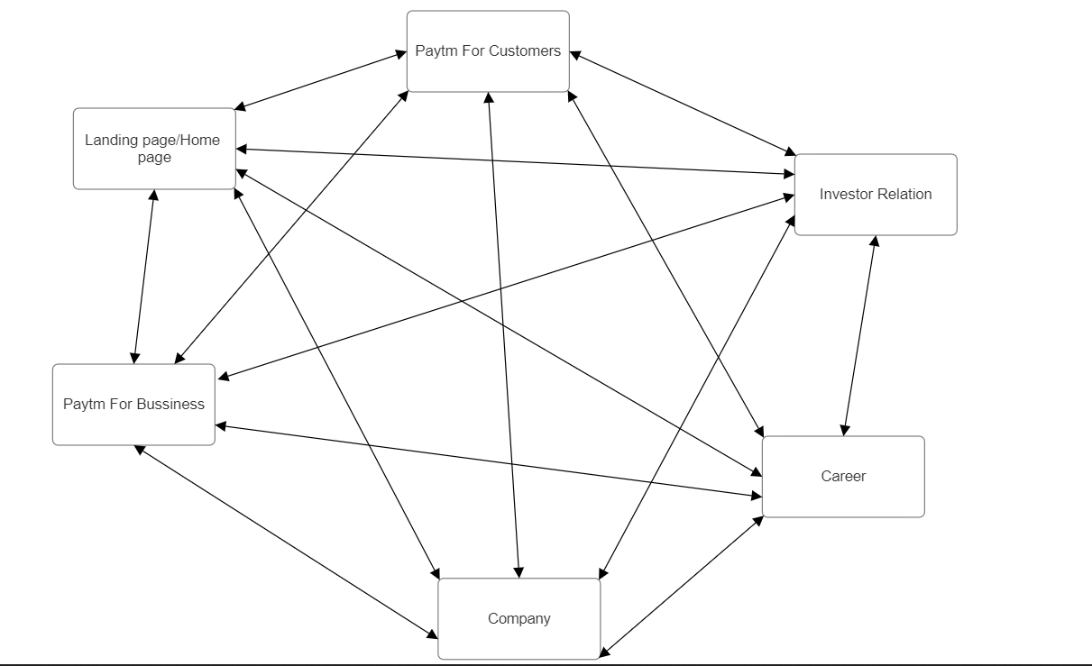

**Home Page:**

**/*paytmclone.html*/**

<!DOCTYPE html>

<html lang="en">

<head>

<meta charset="UTF-8">

<meta name="viewport" content="width=device-width, initial-scale=1.0">

<title>Paytm: Secure & fast UPI Payments,Recharge Mobile & Pay Bills</title>

<script src='https://kit.fontawesome.com/a076d05399.js' crossorigin='anonymous'></script>

<link rel="stylesheet" href="paytmclone.css">

<link rel="icon" href="share-p.avif">

</head>

<body>

<div>

<div id="one">

<a href="paytmclone.html"> <img src="paytm_logo.png" style="height: 55px;width: 170px;margin-top: 20px;margin-left: 190px;"></a>

<nav id="nav1">

<a href="Billpayments.html">Paytm For Customer</a>

<a href="gold.html">Paytm For Business</a>

<a href="investorspage.html">Investor Relation</a>

<a href="about.html">Company</a>

<a href="career.html">Career</a>

</nav>

<div id="one2">

<div style="margin-top: 10px;"> <a style="text-decoration: none;color:white;" href="">Sign In</a></div>

<img src="logoutImg.svg" style="height: 27px;width:27px;margin-top: 5px;">

</div>

</div>

<br><br><br><br><br>

<div id="two" >

<p style="text-align: center;line-height: 50px;"><span style="font-weight: 600;">No Wallet KYC Required </span>&#128525; to pay using UPI on Paytm.<a href="" style="text-decoration: none;color:black;font-weight: 600;">Learn more</a></p>

</div>

<div id="three">

<div id="thre1">

<img src="1654517453942.png" style="width: 16%;height: 80px;border-radius: 12px; box-shadow: 2px 2px 2px;">

<br><br><br><br>

<h2 style="font-size: 55px;">India's Most-loved Payments App</h2><br>

<h3 style="font-size: 21px;font-weight: 400;">Recharge & pay bills, book flights & movie tickets, open a savings account, invest in stocks & mutual funds, and do a lot more.

</h3><br><br><br>

<div id="button3">

<p style="margin-left: 2px;">Download Paytm App <i class="fa fa-apple" aria-hidden="true"></i> </p>

<p><i class="fa fa-apple" aria-hidden="true"></i></p>

<a href=""><img src="png-white-google-play-playstore-logo-symbol-icon-11639742441dhglfjnad1.png" style="width: 100%;height: 20px;"></a>

</div>

</div>

<div id="thre2">

<img src="1656568118664.webp" style="width: 100%;height:500px;">

</div>

</div>

<div id="four">

<br><br><br><br>

<h3 style="color:white;margin-left: 8%;font-size: 32px;">Recharge & Pay Bills on Paytm.</h3>

<div id="four1">

<div id="fr11">

<div id="fr111">

<a href=""><img style="width:70px;width:70px;margin-top:10px;margin-left: 10px;" src="prepai.png"></a>

</div>

<div id="fr112">

<p style="font-size: 19px;text-align: left;line-height: 28px;">Recharge</p>

<h4 style="line-height: 23px;">Prepaid&nbsp;&nbsp;&nbsp;&nbsp; Mobile ></h4>

</div>

</div>

<div id="fr12">

<div id="fr121"><a href=""><img style="width:70px;width:70px;margin-top:10px;margin-left: 10px;" src="elec.png"></a></div>

<div id="fr122">

<p style="font-size: 19px;text-align: left;line-height: 28px;">Pay</p>

<h4 style="line-height: 23px;">Electricity&nbsp;&nbsp;&nbsp;&nbsp;&nbsp;&nbsp; Bill ></h4>

</div>

</div>

<div id="fr13">

<div id="fr131"><a href=""><img style="width:70px;width:70px;margin-top:10px;margin-left: 10px;" src="dth.png"></a></div>

<div id="fr132">

<p style="font-size: 19px;text-align: left;line-height: 28px;">Recharge</p>

<h4 style="line-height: 23px;">DTH&nbsp;&nbsp;&nbsp;&nbsp; Connection ></h4>

</div>

</div>

<div id="fr14">

<div id="fr141"><a href=""><img style="width:70px;width:70px;margin-top:10px;margin-left: 10px;" src="gas.png"></a></div>

<div id="fr142">

<p style="font-size: 19px;text-align: left;line-height: 28px;">Book</p>

<h4 style="line-height: 23px;">Gas&nbsp;&nbsp;&nbsp;&nbsp;&nbsp;&nbsp;&nbsp; Cylinder ></h4>

</div>

</div>

<div id="fr15">

<div id="fr151"><a href=""><img style="width:70px;width:70px;margin-top:10px;margin-left: 10px;" src="broad.png"></a></div>

<div id="fr152">

<p style="font-size: 19px;text-align: left;line-height: 28px;">Pay</p>

<h4 style="line-height: 23px;">Broadband & Landline Bill ></h4>

</div>

</div>

<div id="fr16">

<div id="fr161"><a href=""><img style="width:70px;width:70px;margin-top:10px;margin-left: 10px;" src="edu.png"></a></div>

<div id="fr162">

<p style="font-size: 19px;text-align: left;line-height: 28px;">Pay</p>

<h4 style="line-height: 23px;">Education&nbsp;&nbsp;&nbsp;&nbsp;&nbsp;&nbsp;&nbsp; Fee ></h4>

</div>

</div>

<div id="fr17">

<div id="fr171"><a href=""><img style="width:70px;width:70px;margin-top:10px;margin-left: 10px;" src="all.png"></a></div>

<div id="fr172">

<p style="font-size: 19px;text-align: left;line-height: 28px;">All</p>

<h4 style="line-height: 23px;">Payment&nbsp;&nbsp;&nbsp;&nbsp; Services ></h4>

</div>

</div>

</div>

</div>

<div id="five">

<br><br><br><br>

<h3 style="color:white;margin-left: 8%;font-size: 32px;">Book & Buy on Paytm.</h3>

<div id="five1">

<div id="f11">

<div id="f111">

<a href=""> <img style="width:70px;width:70px;margin-top:10px;margin-left: 10px;" src="mov.png"></a>

</div>

<div id="f112">

<h4 style="font-size: 19px;text-align: left;line-height: 28px;">Movie</h4>

<h4 style="font-size: 19px;text-align: left;line-height: 28px;">Tickets ></h4>

</div>

</div>

<div id="f12">

<div id="f121"><a href=""><img style="width:70px;width:70px;margin-top:10px;margin-left: 10px;" src="flight.png"></a></div>

<div id="f122">

<h4 style="font-size: 19px;text-align: left;line-height: 28px;">Flight</h4>

<h4 style="font-size: 19px;text-align: left;line-height: 28px;">Tickets ></h4>

</div>

</div>

<div id="f13">

<div id="f131"><a href=""><img style="width:70px;width:70px;margin-top:10px;margin-left: 10px;" src="bus.png"></a></div>

<div id="f132">

<h4 style="font-size: 19px;text-align: left;line-height: 28px;">Bus</h4>

<h4 style="font-size: 19px;text-align: left;line-height: 28px;">Tickets ></h4>

</div>

</div>

<div id="f14">

<div id="f141"><a href=""><img style="width:70px;width:70px;margin-top:10px;margin-left: 10px;" src="train.png"></a></div>

<div id="f142">

<h4 style="font-size: 19px;text-align: left;line-height: 28px;">Train</h4>

<h4 style="font-size: 19px;text-align: left;line-height: 28px;">Tickets ></h4>

</div>

</div>

<div id="f15">

<div id="f151"><a href=""><img style="width:70px;width:70px;margin-top:10px;margin-left: 10px;" src="insu.png"></a></div>

<div id="f152">

<h4 style="font-size: 19px;text-align: left;line-height: 28px;">Buy</h4>

<h4 style="font-size: 19px;text-align: left;line-height: 28px;">Insurance ></h4>

</div>

</div>

<div id="f16">

<div id="f161"><a href=""><img style="width:70px;width:70px;margin-top:10px;margin-left: 10px;" src="inter.png"></a></div>

<div id="f162">

<h4 style="font-size: 19px;text-align: left;line-height: 28px;">International</h4>

<h4 style="font-size: 19px;text-align: left;line-height: 28px;">Flights ></h4>

</div>

</div>

<div id="f17">

<div id="f171"><a href=""><img style="width:70px;width:70px;margin-top:10px;margin-left: 10px;" src="stock.webp"></a></div>

<div id="f172">

<h4 style="font-size: 19px;text-align: left;line-height: 28px;">Invest</h4>

<h4 style="font-size: 19px;text-align: left;line-height: 28px;">in Stocks ></h4>

</div>

</div>

</div>

</div>

<div id="large" style="background-color: #f5f7fa;">

<br><br><br><br><br><br><br>

<h2 style="margin-left: 10%;font-size: 42px;">Paytm Payment Instruments</h2><br><br>

<div id="six">

<div id="six1">

<br><br>

<img src="wall.png" style="width: 80px;height: 80px;">

<p style="margin-left: 95px;margin-top: -60px;font-weight: 600;">Paytm</p>

<p style="margin-left: 95px;font-weight: 600;">Wallet</p><br><br><br><br>

<h2 style="font-size: 38px;">The Fastest Way to <br> Pay In-store & Online.</h2><br>

<h4 style="font-weight: 500;font-size: 18px;line-height: 25px;">Load up your Paytm Wallet for free and make payments in a jiffy at over 21 million stores, websites and apps.</h4> <br><br>

<div id="button4">

<p style="margin-left: 2px;">Download Paytm App <i class="fa fa-apple" aria-hidden="true"></i> </p>

<p><i class="fa fa-apple" aria-hidden="true"></i></p>

<a><img src="png-white-google-play-playstore-logo-symbol-icon-11639742441dhglfjnad1.png" style="width: 20px;height: 20px;"></a>

</div>

</div>

<div id="six2">

<img style="width:100%;height:450px;" src="1618577020961-wallet.webp">

</div>

</div>

<br><br><br>

<div id="seven">

<div id="seven1">

<br><br>

<img src="up.png" style="width: 80px;height: 80px;">

<p style="margin-left: 95px;margin-top: -60px;font-weight: 600;">UPI Money</p>

<p style="margin-left: 95px;font-weight: 600;">Transfer</p><br><br><br><br>

<h2 style="font-size: 38px;">Pay anyone directly <br> from your bank<br> account.</h2><br>

<h4 style="font-weight: 500;font-size: 16px;line-height: 25px;">Pay anyone, everywhere. Make contactless & secure payments in-stores or online using Paytm Wallet or Directly from your Bank Account. Plus, send & receive money from anyone.</h4> <br><br>

<div id="button5">

<p style="margin-left: 2px;">Download Paytm App <i class="fa fa-apple" aria-hidden="true"></i> </p>

<p><i class="fa fa-apple" aria-hidden="true"></i></p>

<a><img src="png-white-google-play-playstore-logo-symbol-icon-11639742441dhglfjnad1.png" style="width: 20px;height: 20px;"></a>

</div>

</div>

<div id="seven2">

<img style="width:100%;height:450px;" src="1626342071104-upi transfer.webp">

</div>

</div>

<br><br><br>

<div id="eight">

<div id="eight1">

<br>

<img src="posp.webp" style="width: 150px;height: 80px;"><br><br>

<h2 style="font-size: 38px;">Want it? <br>No more waiting for it.</h2><br><br>

<h4 style="font-weight: 500;font-size: 18px;line-height: 25px;">With Paytm Postpaid, your wishlist doesn't have to be on the waitlist. Shop for the things you want today and pay for them next month.

</h4> <br><br>

<div id="button6">

<p style="margin-left: 2px;"><a style="color: white;text-decoration: none;">Learn More ></a></p>

</div>

</div>

<div id="eight2">

<img style="width:100%;height:450px;margin-left:100px;" src="1626077030984-postpaid.webp">

</div>

</div><br><br><br>

<div id="nine">

<div id="nine1">

<a href="#"><img src="1640242865113-hdfc.png" style="width:170px; height: 95px;"></a><br><br>

<h2 style="font-size: 43px;">Unlimited Cashback Every time</h2><br><br>

<h3 style="font-size: 21px;font-weight: 400;">Paytm HDFC Bank Select Credit Card. A card with assured Cashback and incredible offers.</h3>

</div>

<div id="nine2">

<a href="#"><img src="hdfc.webp"style="width:80%;height:95%;margin-left:10%;margin-top:9%"></a>

</div>

</div>

<div id="ten">

<div id="ten1">

<br><br><br>

<a href="#"><img src="1640242163727-sbi.png" style="width:200px; height: 30px;"></a><br><br>

<h2 style="font-size: 43px;">India’s Most <br>Sincere Credit Card</h2><br><br>

<h3 style="font-size: 21px;font-weight: 400;">Paytm SBI Card SELECT - With Intelligent Features & Great Rewards that Never Expire</h3>

</div>

<div id="ten2">

<a href="#"><img src="sbi.webp"style="width:80%;height:95%;margin-left:10%;margin-top:9%"></a>

</div>

</div>

</div>

<br><br><br><br><br><br><br><br>

<h2 style="font-size: 50px;margin-left: 10%;">Financial Services by Paytm</h2><br><br>

<div id="div1">

<img src="paybank.png" style="width: 250px;height: 40px;"><br><br><br><br>

<h2 style="font-size: 45px;">India's most sincere bank.</h2><br><br>

<h3 style="font-size: 21px;font-weight: 400;">Paytm Payments Bank offers secure, transparent and <br> risk-free banking at your fingertips. With instant account opening, virtual debit card and zero balance requirements, experience the future of banking today.</h3>

<br><br>

<div class="learn">

<p style="margin-left: 2px;"><a style="color: white;text-decoration: none;">Learn More ></a></p>

</div>

</div>

<div id="div2">

<img src="1626076427497-paybank.webp" style="width: 90%;height:500px;margin-left: 10%;">

</div>

<br><br><br><br><br><br><br><br>

<div class="div3">

<br><br><br><br>

<div class="div31">

<img src="stc-bg.webp" style="width: 90%;height:500px;margin-left: 10%;">

</div>

<div class="div32">

<img src="1617696247991-pmoney.webp" style="width: 150px;height: 60px;"><br><br><br><br>

<h2 style="font-size: 42px;">Build Long-term <br>Wealth & Achieve<br> your Goals.</h2><br><br>

<h3 style="font-size: 21px;font-weight: 400;">Investing on Paytm Money is transparent, low-cost and commission-free. Buy stocks & mutual funds that can help you create wealth & realise your dreams.</h3>

<br><br>

<div class="learn">

<p style="margin-left: 2px;"><a style="color: white;text-decoration: none;">Learn More ></a></p>

</div>

</div>

<br><br><br><br><br><br><br><br>

</div>

<br><br><br><br>

<div id="div41">

<img src="pinsu.webp" style="width: 200px;height: 55px;"><br><br><br><br>

<h2 style="font-size: 45px;">Insurance made easy.</h2><br><br>

<h3 style="font-size: 21px;font-weight: 400;">Buying insurance does not have to be tedious, time-consuming & confusing. Paytm Insurance removes the worry of getting insured by making it simple, <br>convenient & easy-to-understand.</h3>

<br><br>

<div class="learn">

<p style="margin-left: 2px;"><a style="color: white;text-decoration: none;">Learn More ></a></p>

</div>

</div>

<div id="div42">

<img src="1653913927257-insu.webp" style="width: 90%;height:450px;margin-left: 10%;">

</div>

<br><br><br><br>

<div class="div5">

<br><br><br><br><br>

<div class="div51">

<img src="1655987252365-ploan.webp" style="width: 90%;height:500px;margin-left: 10%;">

</div>

<div class="div52">

<img src="ploan.png" style="width: 200px;height: 50px;"><br><br><br><br>

<h2 style="font-size: 42px;">Get a Personal Loan in <br>2 Minutes.</h2><br><br>

<h3 style="font-size: 21px;font-weight: 400;">Investing on Paytm Money is transparent, low-cost and commission-free. Buy stocks & mutual funds that can help you create wealth & realise your dreams.</h3>

<br><br>

<div class="learn">

<p style="margin-left: 2px;"><a style="color: white;text-decoration: none;">Learn More ></a></p>

</div>

</div>

<br><br><br><br><br>

</div>

<br><br><br><br><br><br><br><br>

<h2 style="font-size: 50px;margin-left: 10%;">Business Services by Paytm</h2><br><br>

<div class="div6">

<div class="div61">

<br><br><br><br>

<h2 style="font-size: 40px;">Accept payments online with ease</h2><br><br>

<h3 style="font-size: 18px;font-weight: 400;">Grow your business with the payment gateway that powers India’s largest brands and even the Paytm App</h3>

<br><br>

<div class="learn">

<p style="margin-left: 2px;"><a style="color: white;text-decoration: none;">Learn More ></a></p>

</div>

</div>

<div class="div62">

<img src="1626077000254-ponline.webp" alt="" style="width:100%;height:500px">

</div>

</div>

<br><br><br>

<div class="div7">

<div class="div71">

<br><br><br>

<h2 style="font-size: 40px;">In-shop payments powered by Paytm.</h2><br><br>

<h3 style="font-size: 18px;font-weight: 400;">Millions of small & big businesses use Paytm to accept payments anywhere any time with a wide range of solutions for all kind of merchants</h3>

<br><br>

<div class="learn">

<p style="margin-left: 2px;"><a style="color: white;text-decoration: none;">Learn More ></a></p>

</div>

</div>

<div class="div72">

<img src="1656675942486-shopping.webp" alt="" style="width:100%;height:350px">

</div>

</div>

<br><br><br><br><br><br><br><br><br>

<h2 style="font-size: 40px;margin-left: 10%;">Business Tools to help <br>your business grow</h2><br><br><br><br><br>

<div class="div8">

<div class="div81">

<div class="div82">

<img src="1626081565192-POS.webp" style="width:100%;height: 250px;">

</div>

<br>

<h2 style="font-size: 28px;">POS Billing <br>Software</h2><br><br>

<h3 style="font-size: 20px;font-weight: 400;">Say Hello to Smart Retail Business Management</h3><br>

<a href="#" style="text-decoration: none;color:black;font-weight: bold;">Learn More</a>

</div>

<div class="div81">

<div class="div82">

<img src="1626081071077-bapp.webp" style="width:100%;height: 250px;">

</div>

<br>

<h2 style="font-size: 28px;">Paytm for <br>Business App</h2><br><br>

<h3 style="font-size: 20px;font-weight: 400;">Everything you need to manage your business <br> on your phone</h3><br>

<a href="#" style="text-decoration: none;color:black;font-weight: bold;">Learn More</a>

</div>

<div class="div81">

<div class="div82">

<img src="1656568216166-ad.webp" style="width:100%;height: 250px;">

</div>

<br>

<h2 style="font-size: 28px;">Advertise on<br>Paytm</h2><br><br>

<h3 style="font-size: 20px;font-weight: 400;">Grow your business by advertising on India’s <br>largest mobile business </h3><br>

<a href="#" style="text-decoration: none;color:black;font-weight: bold;">Learn More</a>

</div>

<div class="div81">

<div class="div82">

<img src="1626081814411-bkhata.webp" style="width:100%;height: 250px;">

</div>

<br>

<h2 style="font-size: 28px;">Business <br>Khata</h2><br><br>

<h3 style="font-size: 20px;font-weight: 400;">Managing Khata made<br> easy</h3><br>

<a href="#" style="text-decoration: none;color:black;font-weight: bold;">Learn More</a>

</div>

</div>

<br><br><br><br><br><br><br>

<div id="div9">

<div class="div91">

<img src="1617696247991-pmoney.webp" style="width: 150px;height: 60px;"><br><br>

<br><br>

<h2 style="font-size: 16px;font-weight: 500;">Get started on wealth <br>creation journey with Zero brokerage fee & no hidden charges.</h2><br>

<a href="#" style="text-decoration: none;color:#00baf2;font-size: large;">Learn More</a>

</div>

<div class="div92">

<div class="div9">

<img src="invstock.webp" style="border-radius: 5px;height:170px;border: #00baf2 5px solid;width: 175px;"><br><br>

<center><a href="#" style="text-decoration: none;color:white;font-weight: bold;">Invest in Stocks</a></center>

</div>

<div class="div9">

<img src="ipo.webp" style="border-radius: 5px;height:170px;border: #00baf2 5px solid;width: 175px;"><br><br>

<center><a href="#" style="text-decoration: none;color:white;font-weight: bold;">Apply for IPO</a></center>

</div>

<div class="div9">

<img src="etf.webp" style="border-radius: 5px;height:170px;border: #00baf2 5px solid;width: 175px;"><br><br>

<center><a href="#" style="text-decoration: none;color:white;font-weight: bold;">Invest in ETFs</a></center>

</div>

<div class="div9">

<img src="gold.webp" style="border-radius: 5px;height:170px;border: #00baf2 5px solid;width: 175px;"><br><br>

<center><a href="#" style="text-decoration: none;color:white;font-weight: bold;">Buy Gold</a></center>

</div>

</div>

</div>

<br><br><br><br><br>

<div id="div10">

<div class="div91">

<img src="ptrav.webp" style="width: 150px;height: 60px;"><br><br>

<br><br>

<h2 style="font-size: 16px;font-weight: 500;">Best travel solutions with <br>quick ticket bookings, great<br> offers and easy refunds</h2><br>

<a href="#" style="text-decoration: none;color:#00baf2;font-size: large;" >Learn More</a>

</div>

<div class="div92">

<div class="div9">

<br><br>

<img src="fl.webp" style="height:70px;width: 70px;margin-left: 5%;"><br><br>

<a href="#" style="text-decoration: none;color:white;font-weight: bold;line-height: 22px;">&nbsp;Flat 14%<br>&nbsp;Cashback</a><br>

<a href="#" style="text-decoration: none;color:white;font-weight: bold;font-size: 14px;line-height: 22px;">&nbsp;With Code</a><br>

<a href="#" style="text-decoration: none;color:white;font-weight: bold;font-size: 14px;">&nbsp;WELCOMEFLIGHT</a>

</div>

<div class="div9">

<br><br>

<img src="pro.webp" style="height:70px;width: 70px;margin-left: 5%;"><br><br>

<a href="#" style="text-decoration: none;color:white;font-weight: bold;line-height: 22px;">&nbsp;100% Refund</a><br>

<a href="#" style="text-decoration: none;color:white;font-weight: bold;font-size: 14px;line-height: 22px;">&nbsp;With Paytm's</a><br>

<a href="#" style="text-decoration: none;color:white;font-weight: bold;font-size: 14px;line-height: 22px;">&nbsp;Cancellation Protect</a>

</div>

<div class="div9">

<br><br>

<img src="happybus.webp" style="height:70px;width: 70px;margin-left: 5%;"><br><br>

<a href="#" style="text-decoration: none;color:white;font-weight: bold;line-height: 22px;">&nbsp;Flat 10%<br>&nbsp;Cashback</a><br>

<a href="#" style="text-decoration: none;color:white;font-weight: bold;font-size: 14px;line-height: 22px;">&nbsp;With Code HAPPYBUS</a><br>

</div>

<div class="div9">

<br><br>

<img src="sani.webp" style="height:70px;width: 70px;margin-left: 5%;"><br><br>

<a href="#" style="text-decoration: none;color:white;font-weight: bold;line-height: 22px;">&nbsp;Sanitised Bus <br>&nbsp;Options With<br>&nbsp;TravelSafe+</a>

</div>

</div>

</div>

<br><br><br><br><br><br><br><br><br>

<div id="div11">

<br><br><br><br>

<div style="width: 80%;height:100px;margin-left:10%;display: flex;border-bottom: 1px solid #ccc">

<br>

<h3 style="font-size: 20px;font-weight: 600;">Download Paytm App <br>to Pay from anywhere</h3>

<a href=""><img src="downloadApple.svg" style="margin-left: 30px;"></a>

<a href=""><img src="downloadGoogle.svg" style="margin-left: 30px;"></a>

</div>

<div style="width:140px;height:40px;float:right;margin-right: 10%;margin-top: -90px;display: flex;justify-content: space-between;">

<a href=""><img src="twitter.svg" style="height: 25px;" alt=""></a>

<a href=""><img src="instagram.svg" style="height: 25px;" alt=""></a>

<a href=""><img src="facebook.svg" style="height: 25px;" alt=""></a>

</div>

<br><br><br><br>

<div class="last">

<a href=""> <img src="plus.svg"></a>

<p style="margin-left: 10px;"> Investor Relations</p>

</div>

<div class="last">

<a href=""> <img src="plus.svg"></a>

<p style="margin-left: 10px;"> More about Paytm</p>

</div>

<div class="last">

<a href=""> <img src="plus.svg"></a>

<p style="margin-left: 10px;"> Company</p>

</div>

<div class="last">

<a href=""> <img src="plus.svg"></a>

<p style="margin-left: 10px;"> Career</p>

</div>

<div class="last">

<a href=""> <img src="plus.svg"></a>

<p style="margin-left: 10px;"> Recharge & pay bills</p>

</div>

<div class="last">

<a href=""> <img src="plus.svg"></a>

<p style="margin-left: 10px;"> Pay Loan EMI, Insurance Premiums & Education Fee</p>

</div>

<div class="last">

<a href=""> <img src="plus.svg"></a>

<p style="margin-left: 10px;"> Book Travel & Entertainment</p>

</div>

<div class="last">

<a href=""> <img src="plus.svg"></a>

<p style="margin-left: 10px;"> Investments & Miscellaneous/p>

</div>

<div class="last">

<a href=""> <img src="plus.svg"></a>

<p style="margin-left: 10px;"> Loans and Credit Cards</p>

</div>

<div class="last">

<a href=""> <img src="plus.svg"></a>

<p style="margin-left: 10px;"> Financial Tools & Calculators</p>

</div>

</div>

<div style="background-color: #00baf2;height:10px;"></div>

<div style="background-color: #002970;height:10px;"></div>

</div>

</body>

</html>

**/*paytmclone.css*/**

*{

margin:0px;

font-family: sans-serif;

box-sizing: border-box;

}

#one{

width: 100%;

height: 90px;

box-shadow: 0px 2px 4px;

position: fixed;

background-color: white;

z-index: 9999;

}

#nav1{

margin-left: 25%;

margin-top:-40px;

font-size: 16px;

font-weight: 600;

}

#nav1 a{

padding-right: 25px;

padding-left: 25px;

text-decoration: none;

padding-top: 10px;

padding-bottom: 10px;

color: black;

}

#nav1 a:hover{

background-color: rgb(234, 234, 234);

}

#nav a:visited{

color: black;

}

#bt1{

width:120px;

height: 40px;

float: right;

}

#one2{

width:8%;

height: 40px;

background-color: #00baf2;

border-radius: 50px;

float: right;

color:white;

border: none;

font-size: 17px;

margin-right: 150px;

margin-top: -30px;

display: flex;

justify-content: space-around;

}

#one2:hover{

background-color: #002970;

}

#two{

height:50px;

background-color: rgb(234, 234, 234);

}

#three{

width: 100%;

height:700px;

background-color: white;

position: relative;

}

#thre1{

width:32%;

height: 500px;

background-color:white;

position: absolute;

top: 100px;

margin-left: 9%;

}

#thre2{

width:34%;

height: 500px;

background-color:white;

margin-top:100px;

float: right;

}

#button3,#button4,#button5{

width:50%;

height: 45px;

background-color: black;

border-radius: 30px;

color: white;

display: flex;

justify-content: space-around;

align-items: center;

}

#button3:hover{

border: 1px solid black;

background-color: white;

color: black;

}

#button4:hover{

border: 1px solid black;

background-color: white;

color: black;

}

#button5:hover{

border: 1px solid black;

background-color: white;

color: black;

}

#button6{

width:200px;

height: 50px;

background-color:#002970;

border-radius: 30px;

color: white;

display: flex;

justify-content: space-around;

align-items: center;

}

#button6:hover{

background-color: #00baf2;

}

#four{

width:100%;

height:390px;

background: #00baf2;

position: relative;

}

#four1{

width:84%;

height: 200px;

margin-left:8%;

position: absolute;

top:140px;

display: flex;

justify-content: space-between;

color: white;

}

#fr11,#fr12,#fr13,#fr14,#fr15,#fr16,#fr17{

width: 10%;

height: 200px;

border-radius: 10px;

}

#fr111,#fr121,#fr131,#fr141,#fr151,#fr161,#fr171{

width:100%;

height:100px;

border-top-left-radius: 10px;

border-top-right-radius: 10px;

}

#four1 div:hover{

background-color:#169dc7 ;

}

#five{

width:100%;

height:380px;

background: #002970;

position: relative;

}

#five1{

width:84%;

height: 200px;

margin-left:8%;

position: absolute;

top:130px;

display: flex;

justify-content: space-between;

color: white;

}

#f11,#f12,#f13,#f14,#f15,#f16,#f17{

width: 10%;

height: 180px;

border-radius: 10px;

}

#f111,#f121,#f131,#f141,#f151,#f161,#f171{

width:100%;

height:100px;

border-top-left-radius: 10px;

border-top-right-radius: 10px;

}

#five1 div:hover{

background-color: #003da8;

}

#large{

width: 100%;

height: 3150px;

}

#six,#seven,#eight{

width: 80%;

margin-left: 10%;

height:650px;

background-color: white;

border-radius: 10px;

display: flex;

position: relative;

justify-content:space-around;

}

#six1,#seven1,#eight1{

height: 450px;

width: 40%;

position: absolute;

top:100px;

left:10%;

background-color: white;

}

#six2,#seven2,#eight2{

height: 450px;

width: 40%;

position: absolute;

top:100px;

left:50%;

background-color: white;

}

#nine{

width: 38%;

margin-left: 10%;

height:700px;

background-color:white;

border-radius: 10px;

}

#ten{

width: 38%;

margin-left: 52%;

height: 700px;

background-color: white;

border-radius: 15px;

margin-top: -700px;

}

#nine1,#ten1{

margin-left: 10%;

width: 80%;

height: 50%;

background-color: white;

}

#div1{

width: 36%;

margin-left: 10%;

height:500px;

background-color:white;

border-radius: 10px;

}

#div2{

width: 36%;

margin-left: 54%;

height: 500px;

background-color:white;

border-radius: 15px;

margin-top: -500px;

}

.learn{

width:200px;

height: 50px;

background-color:#002970;

border-radius: 30px;

color: white;

display: flex;

justify-content: space-around;

align-items: center;

}

.learn:hover{

background-color: #00baf2;

}

.div3{

background-color: #f5f7fa;

background-image: url('gray-spike.avif');

background-size: cover;

}

.div31{

width: 36%;

margin-left: 10%;

height:500px;

border-radius: 10px;

}

.div32{

width: 36%;

margin-left: 54%;

height: 500px;

border-radius: 15px;

margin-top: -500px;

}

#div41{

width: 36%;

margin-left: 10%;

height:500px;

background-color:white;

border-radius: 10px;

}

#div42{

width: 36%;

margin-left: 54%;

height: 500px;

background-color:white;

border-radius: 15px;

margin-top: -500px;

}

.div5{

background-color: #f5f7fa;

}

.div51{

width: 36%;

margin-left: 10%;

height:500px;

border-radius: 10px;

}

.div52{

width: 36%;

margin-left: 54%;

height: 500px;

border-radius: 15px;

margin-top: -500px;

}

.div6{

width: 80%;

height: 650px;

background-color: #f5f7fa;

border-radius: 10px;

margin-left: 10%;

display: flex;

justify-content: space-around;

}

.div61{

width:36%;

height:450px;

margin-top: 100px;

margin-left: 12%;

}

.div62{

width:40%;

margin-top:80px;

height:500px;

margin-left: 230px;

}

.div7{

width: 80%;

height: 500px;

background-color: #f5f7fa;

border-radius: 10px;

margin-left: 10%;

display: flex;

justify-content: space-around;

}

.div71{

width:36%;

height:350px;

margin-top: 75px;

margin-left: 12%;

}

.div72{

width:40%;

margin-top:75px;

height:350px;

margin-left: 230px;

}

.div8{

width:80%;

height:500px;

background-color:white;

display: flex;

justify-content: space-between;

margin-left: 10%;

}

.div81{

width:23%;

height: 500px;

background-color: white;

}

.div82{

height:250px;

}

#div9{

margin-left: 15%;

width:80%;

height:250px;

display: flex;

position: relative;

}

.div91{

width:20%;

height:250px;

background-color: white;

}

.div92{

width:75%;

height:250px;

background-color: white;

display: flex;

overflow: hidden;

}

.div9{

height: 250px;

width:175px;

background-color:#00baf2;

margin-left: 5%;

border-radius: 5%;

box-sizing: border-box;

}

#div10{

margin-left: 15%;

width:80%;

height:250px;

display: flex;

position: relative;

}

.div92 div:hover{

background-color:#169dc7 ;

}

#div11{

background-color: #f5f7fa;

height: 800px;

}

.last{

width: 80%;

margin-left:10%;

padding: 15px 0;

cursor: pointer;

position: relative;

display: flex;

font-size: 14px;

color: #505050;

font-weight: 700;

}

.last ::after{

content: "";

border-bottom: 2px solid #ccc;

}

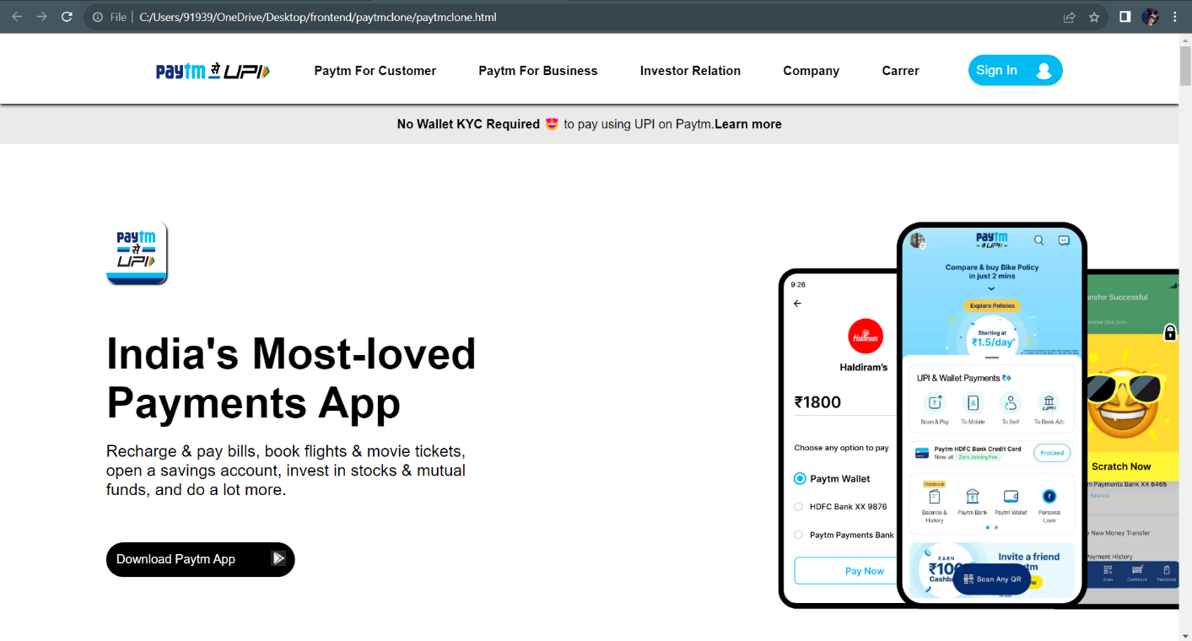

**Paytm-HomePage-ScreenShot-1**

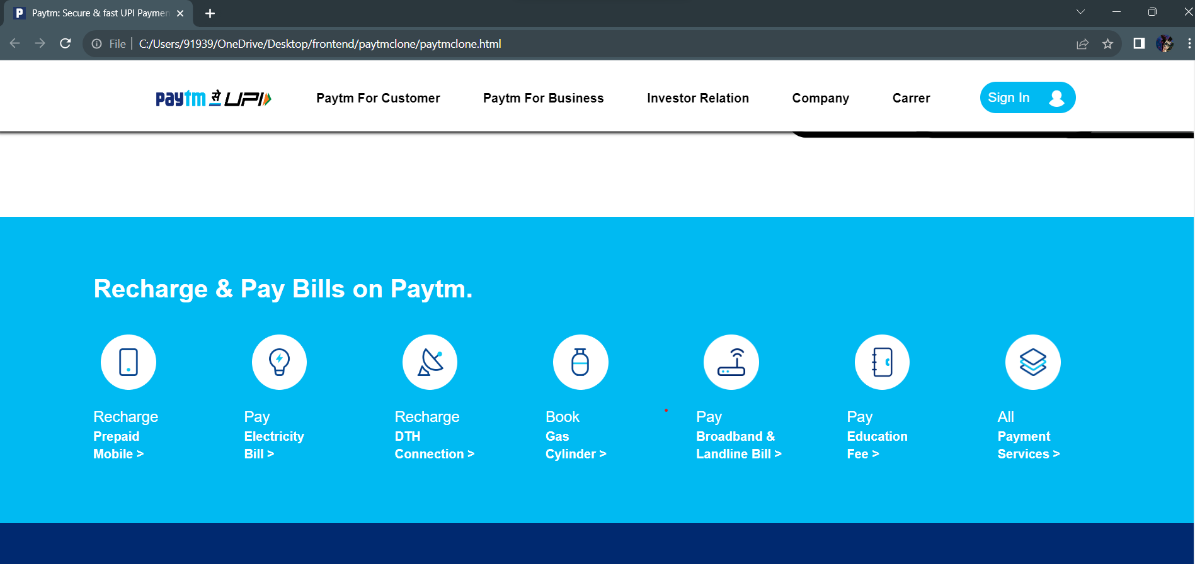

**Paytm-HomePage-ScreenShot-2**

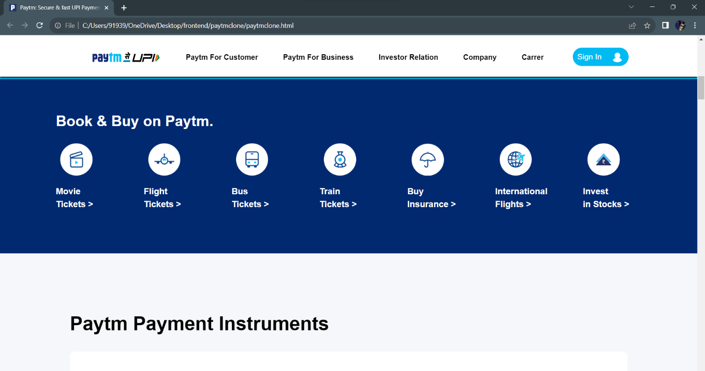

**Paytm-HomePage-ScreenShot-3**

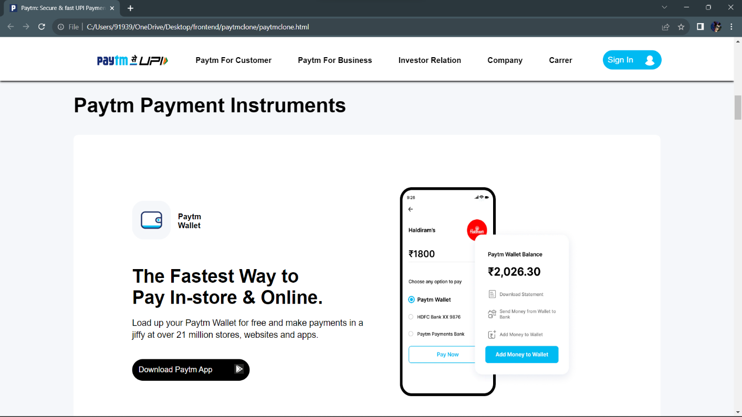

**Paytm-HomePage-ScreenShot-4**

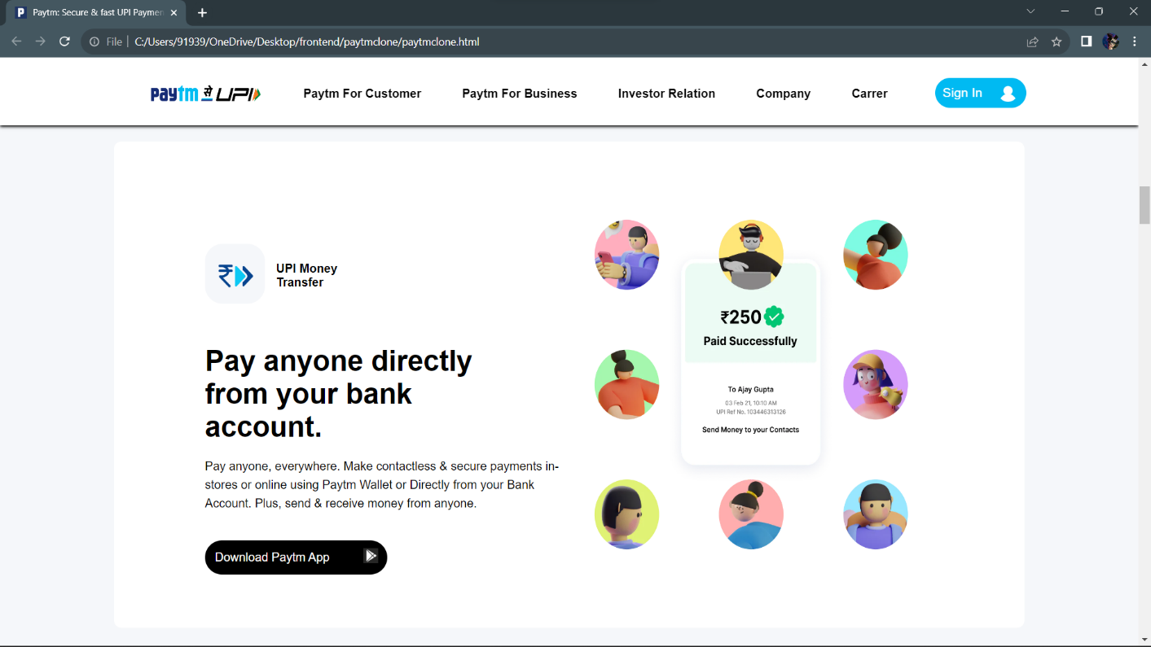

**Paytm-HomePage-ScreenShot-5**

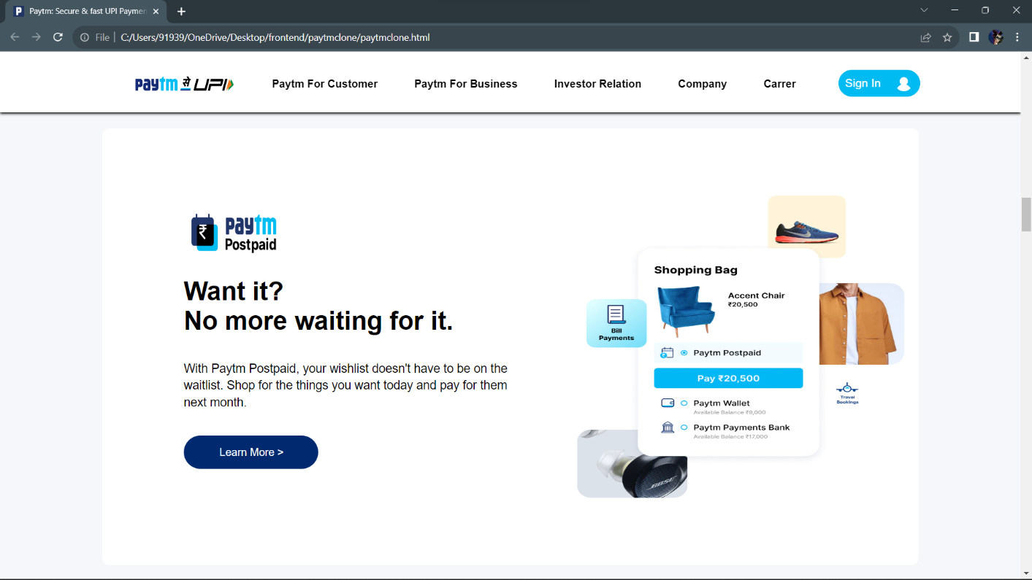

**Paytm-HomePage-ScreenShot-6**

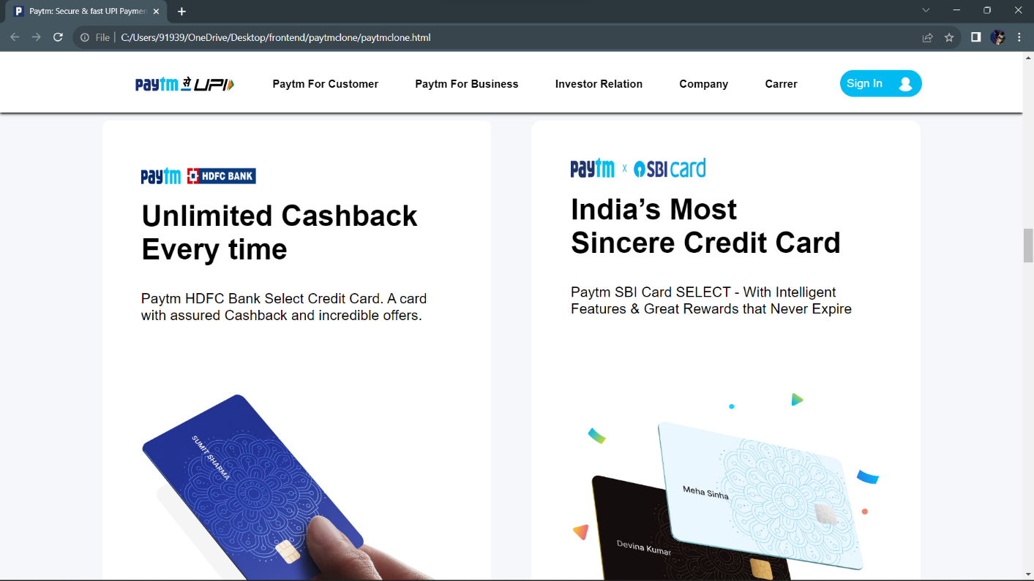

**Paytm-HomePage-ScreenShot-7**

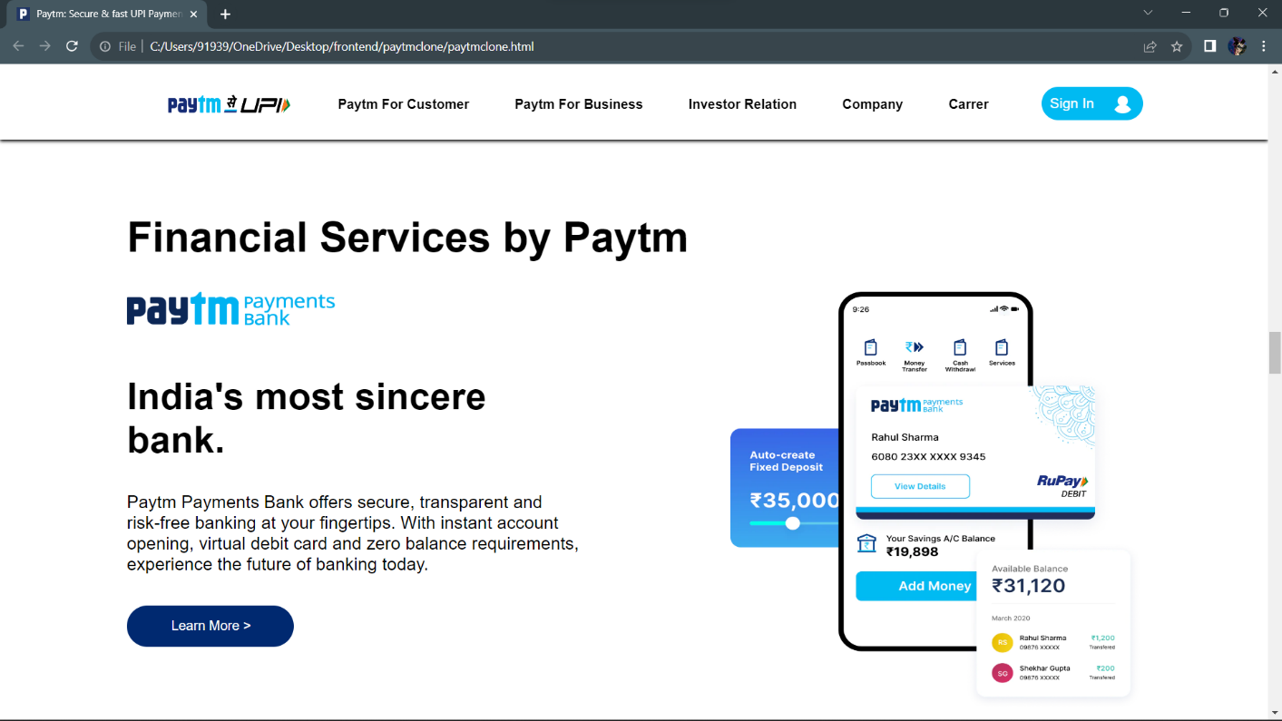

**Paytm-HomePage-ScreenShot-8**

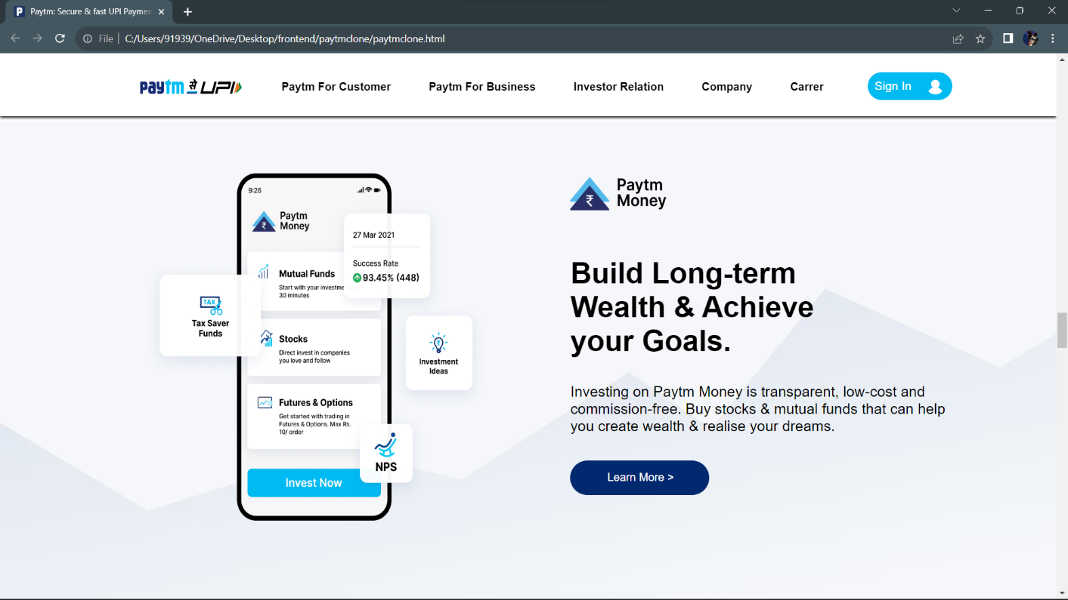

**Paytm-HomePage-ScreenShot-9**

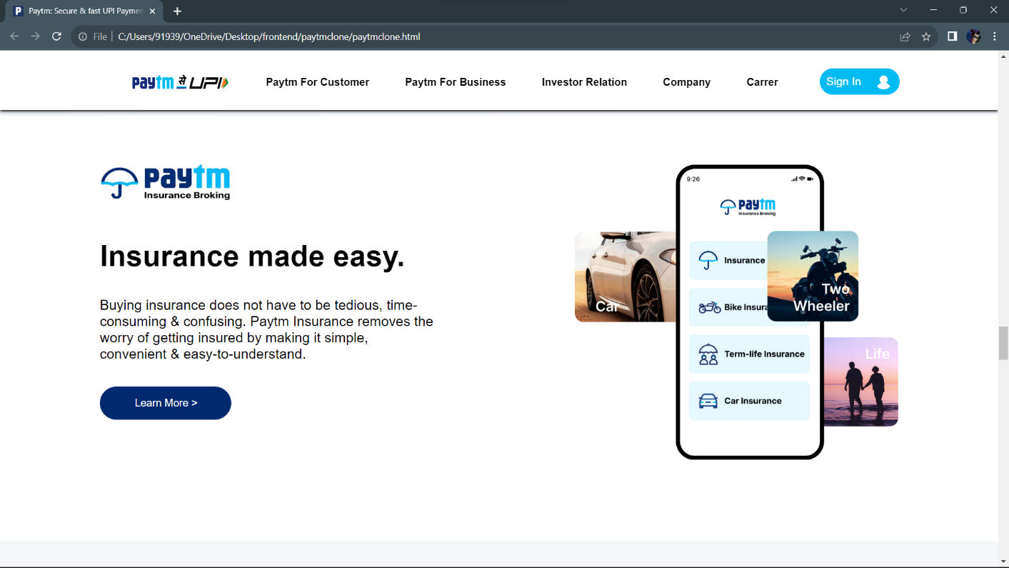

**Paytm-HomePage-ScreenShot-10**

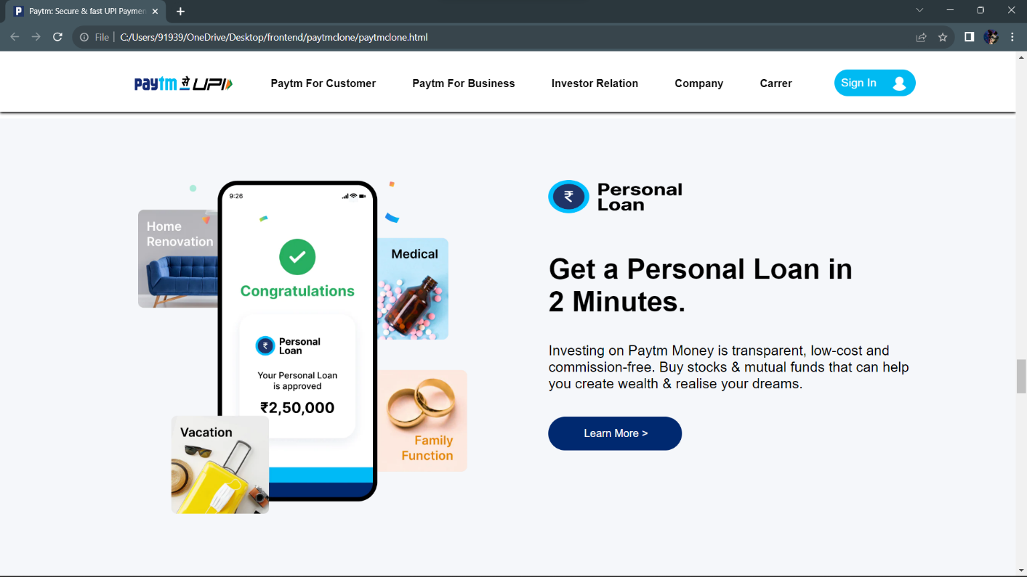

**Paytm-HomePage-ScreenShot-11**

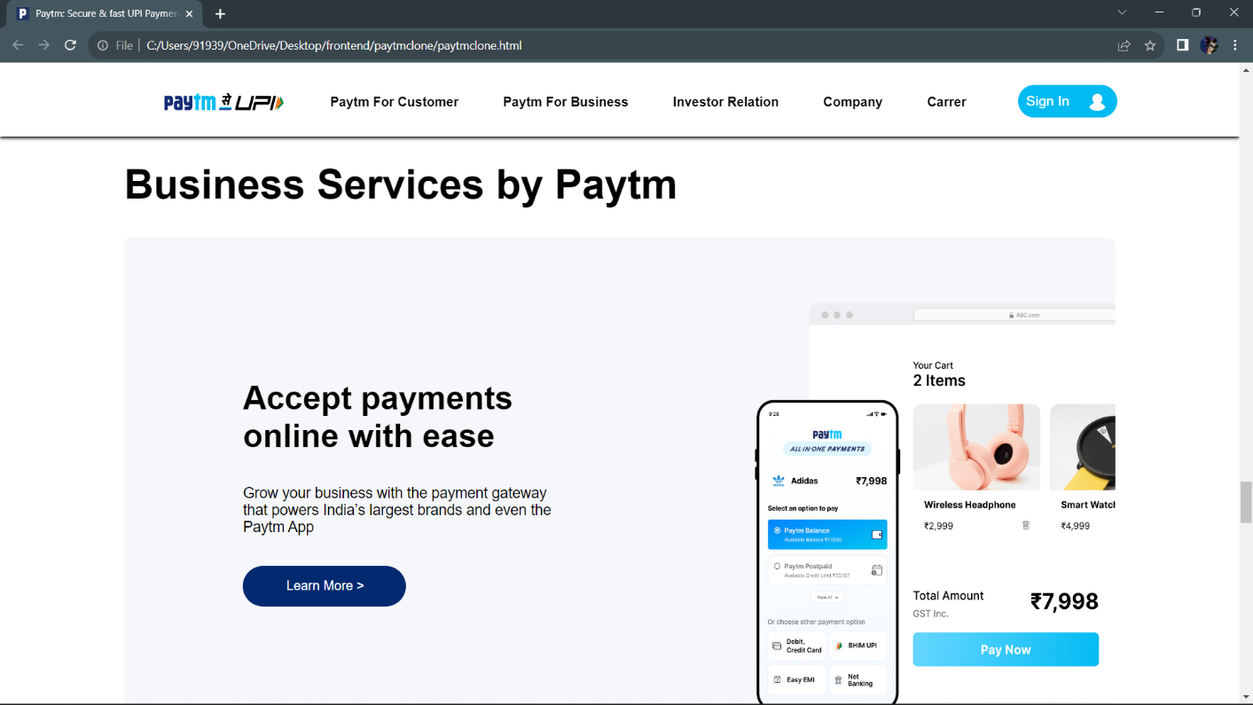

**Paytm-HomePage-ScreenShot-12**

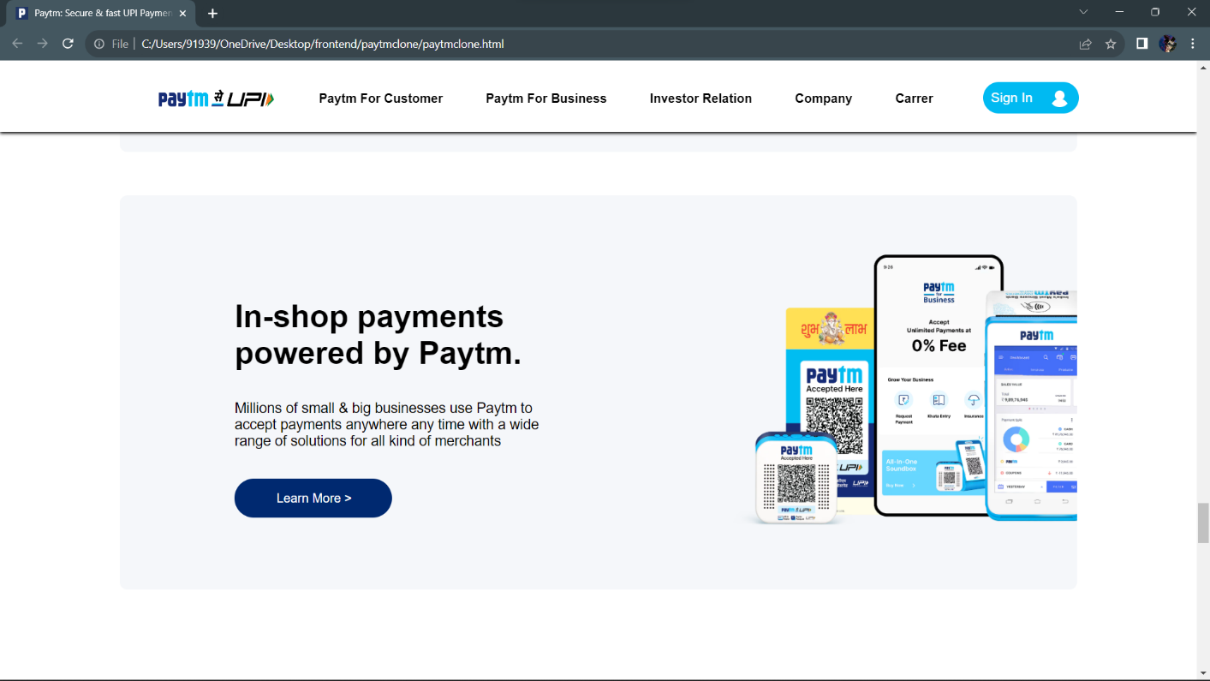

**Paytm-HomePage-ScreenShot-13**

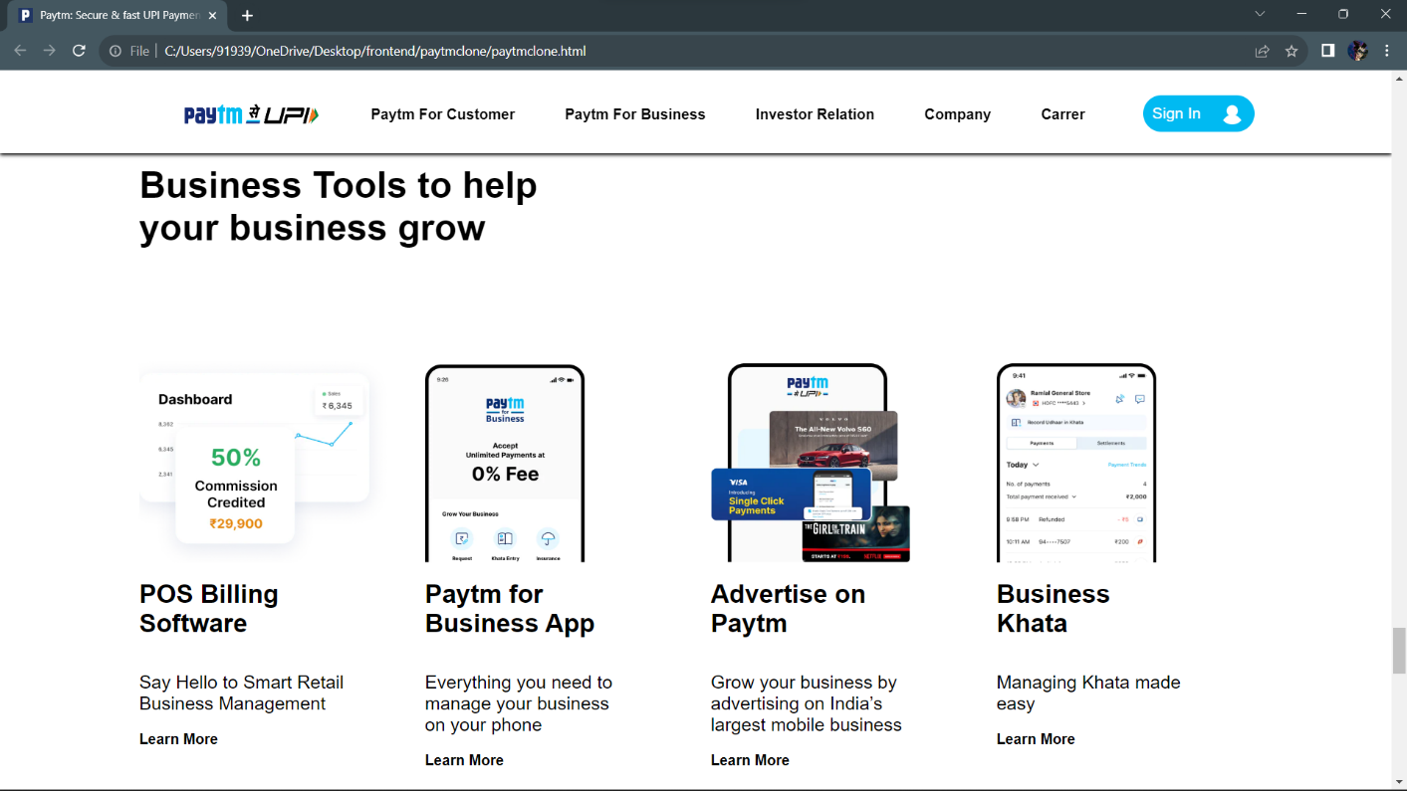

**Paytm-HomePage-ScreenShot-14**

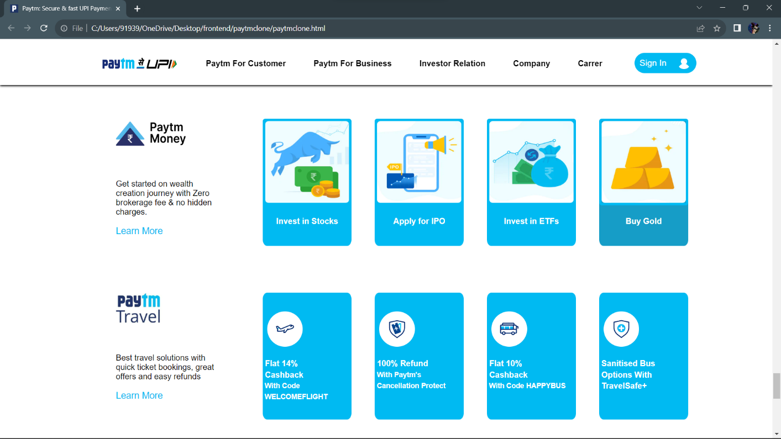

**Paytm-HomePage-ScreenShot-15**

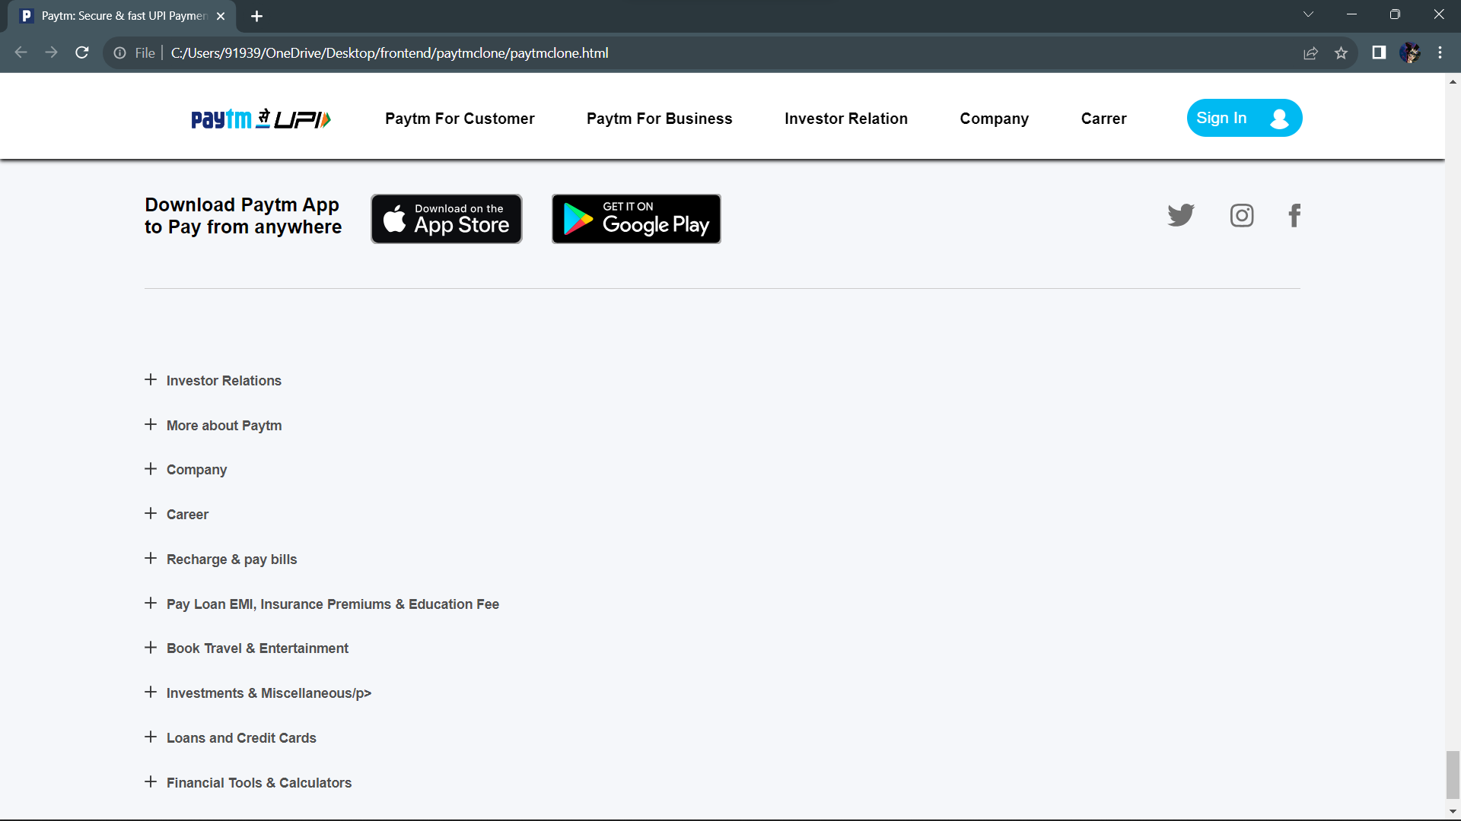

**Paytm-HomePage-ScreenShot-16**

**Conclusion**: -

Creating a Paytm clone project using HTML and CSS has been a rewarding and educational journey.

**Technical Proficiency:** Developing a Paytm clone required a solid understanding of HTML and CSS. Through this project, you've honed your skills in structuring web pages, styling elements, and creating a visually appealing user interface.

**User Interface Design:** Successfully emulating Paytm's user interface demonstrates your design skills. You've worked on layout design, typography, colour schemes, and the arrangement of elements to create a user-friendly and aesthetically pleasing website.

**Responsive Design:** Adapting clone project for different screen sizes and devices is a vital aspect of modern web development. Learning to make project responsive using media queries and other techniques is a valuable skill.

**Project Management:** Building a clone project required planning and organization. I broken down the project into manageable tasks, set milestones, and followed a structured approach. This experience is transferable to real-world web development projects.

**Testing and Debugging:** During the development process, I encountered and resolved various issues. This experience has improved your debugging skills, enabling you to identify and rectify problems in your code efficiently.

**Ethical Considerations:** While creating clone projects for educational purposes is acceptable, it's essential to remember the importance of respecting intellectual property and copyrights. Ensured that I didn't used or distributed clone projects for commercial gain without proper authorization.

**Future Growth:** Paytm clone project is just the beginning of my web development journey. Consider expanding your skills by exploring JavaScript to add interactivity and functionality to my projects. Delve into backend development, databases, and other web technologies to create more advanced applications.

In conclusion, My Paytm clone project using HTML and CSS has provided me with valuable insights into web development and design. It showcased my ability to create a user-friendly website and sets the stage for your continued growth in the field. Keep building, learning, and exploring new technologies to stay ahead in the ever-evolving world of web development.